**LAB 6 Q5 TO Q8**

**QUESTION NO 5:**

**EXPLANATION:**

WE CANNOT HANDLE THIS QUETSION WITH SWITCH CASE BECUASE THE RANGES ARE NOT DEFINED HERE OR IT CAN'T BE DONE WITH SWITCH CASE IT CAN EASILY DONE BY

USING IF ELSE STATEMENT SO INSTEAD OF USING SWITCH WE HAVE TO USE IF ELSE IN SWITCH CASE WE COMPARE WITH A FIXED VALUE BUT HERE THE VALUE IS NOT FIXED IT CHANGES WE CANNOT COMARE THE VALUE.

INPUT:

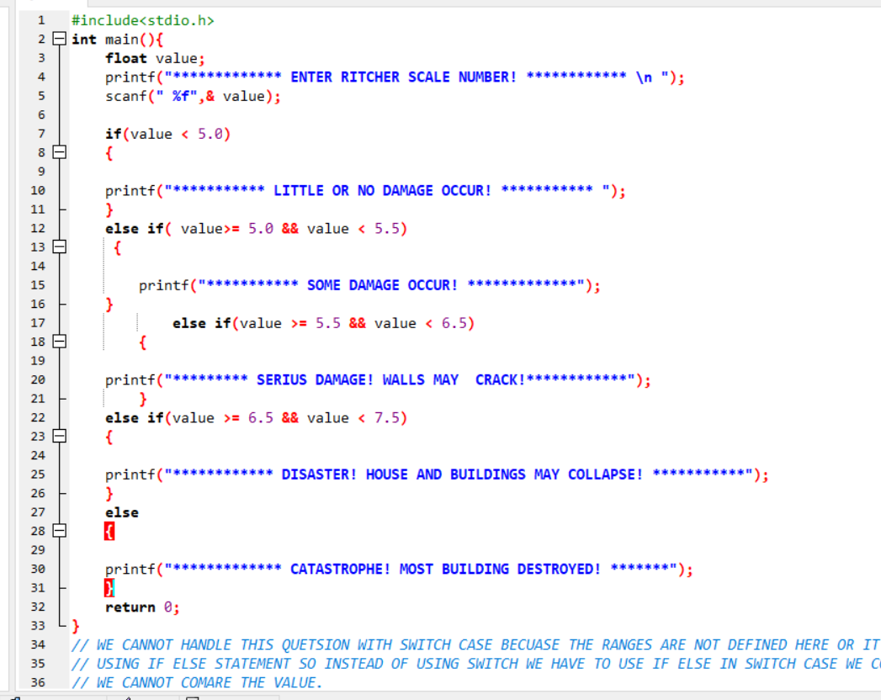

OUTPUT:

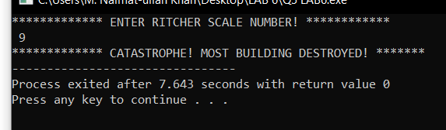

**QUESTION NO 6:**

INPUT:

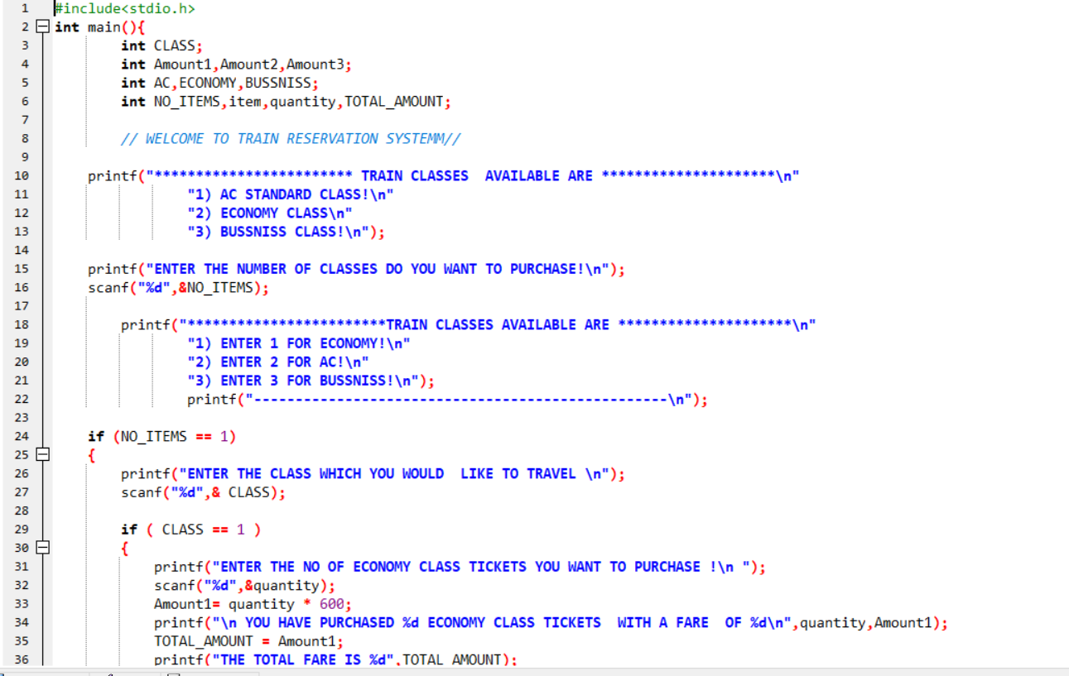

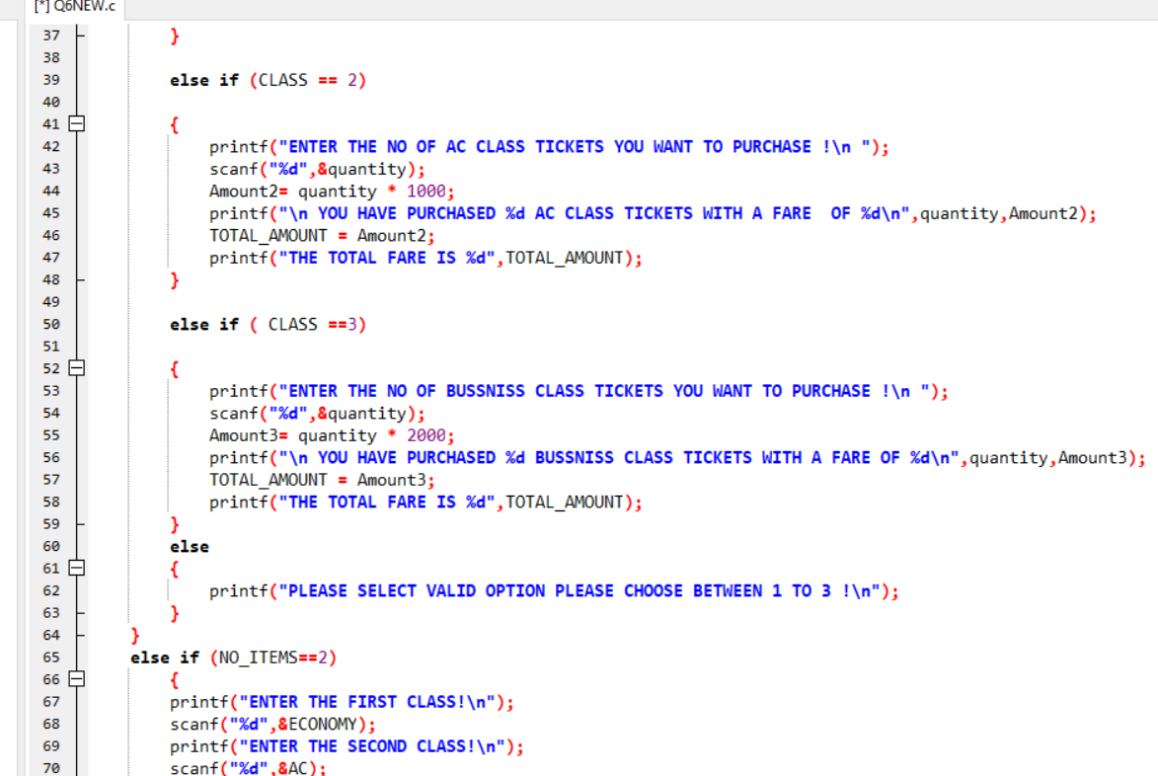

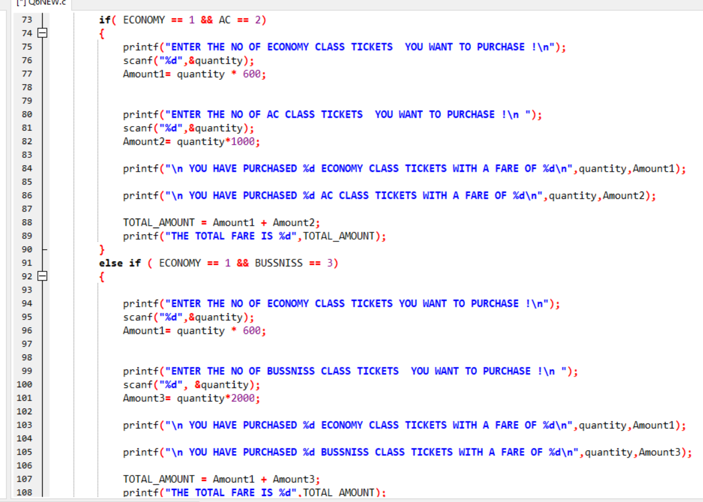

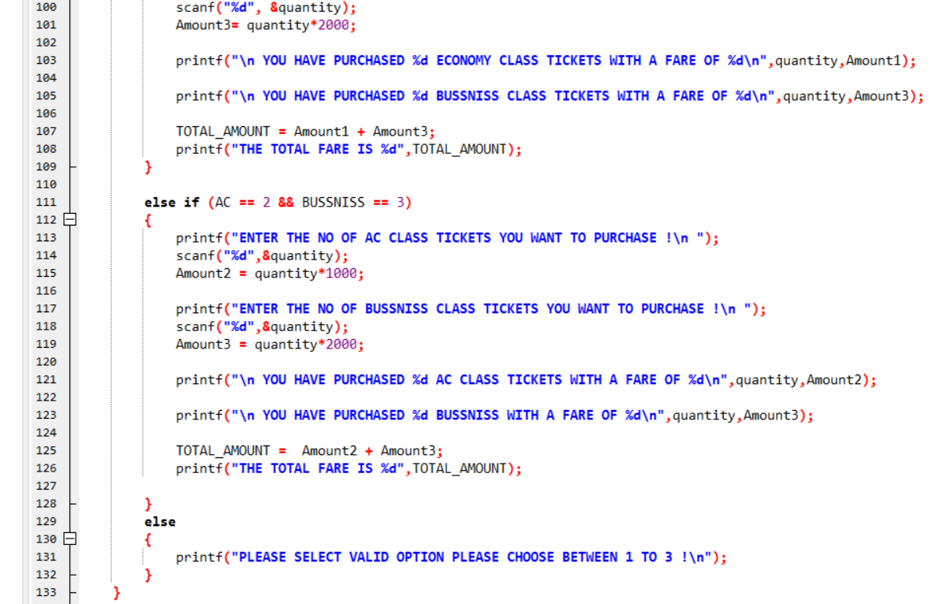

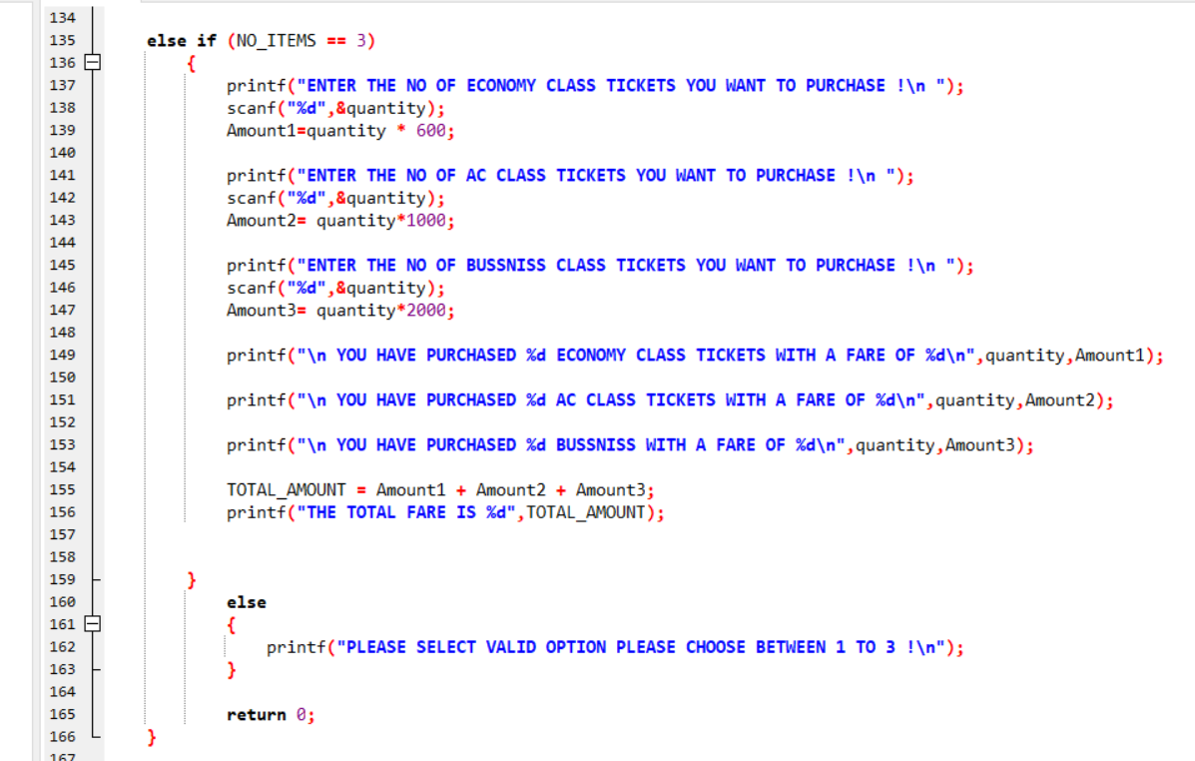

OUTPUT:

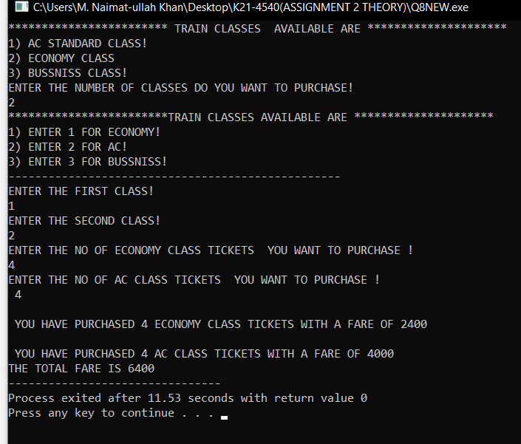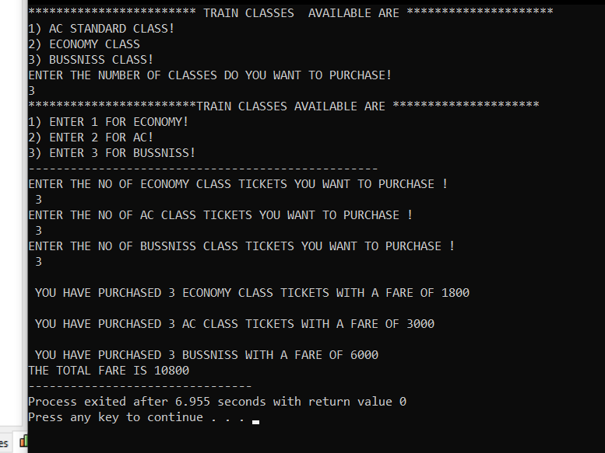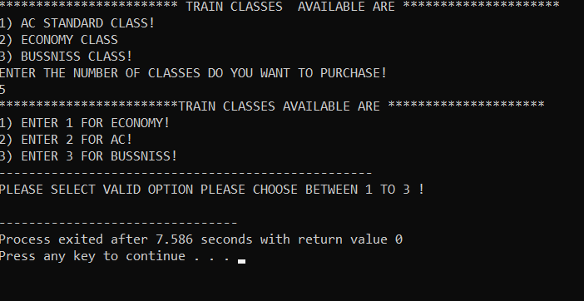

**QUESTION NO 7:**

INPUT:

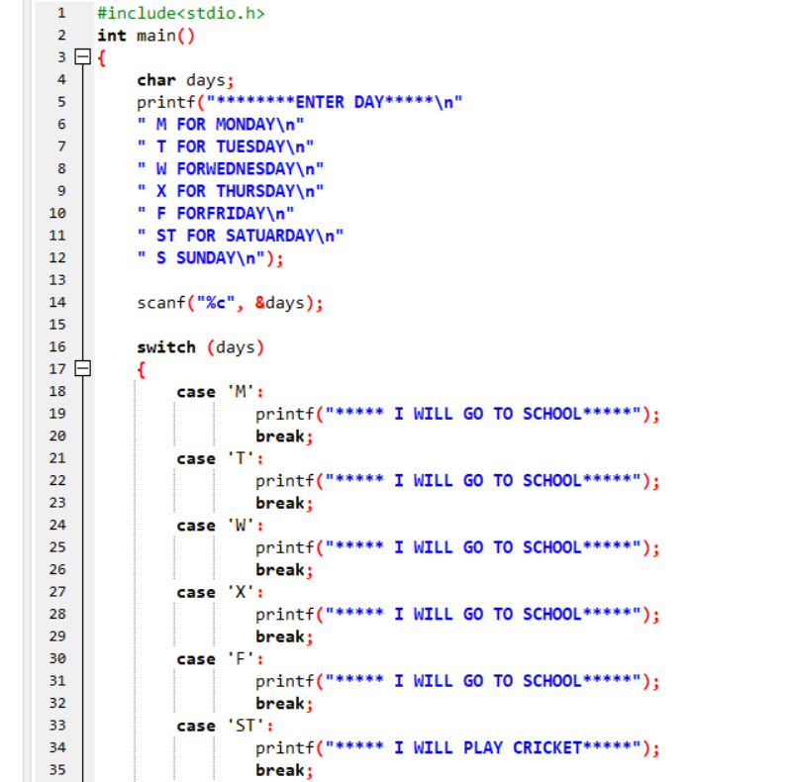

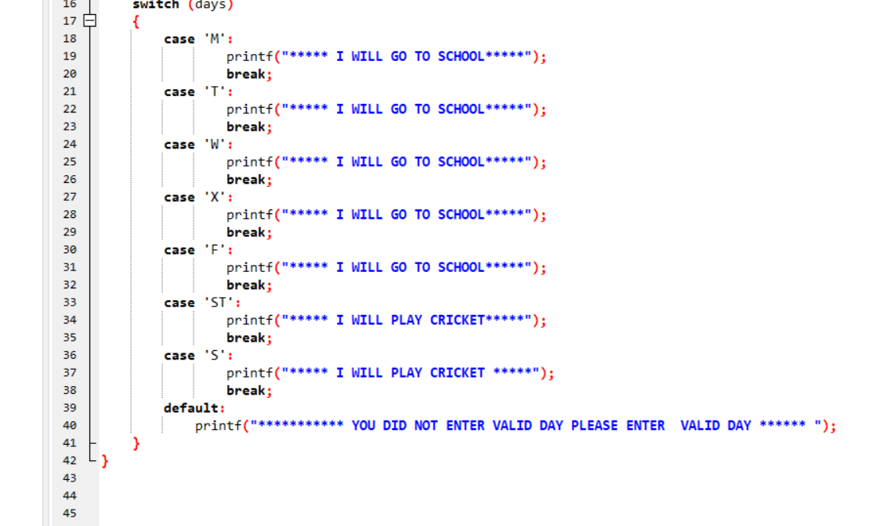

OUTPUT:

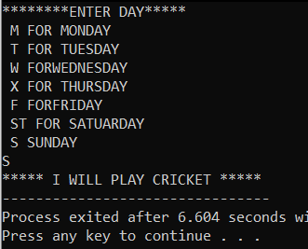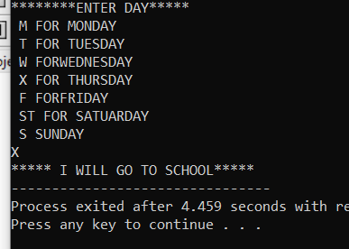

**QUESTION NO 8:**

INPUT:

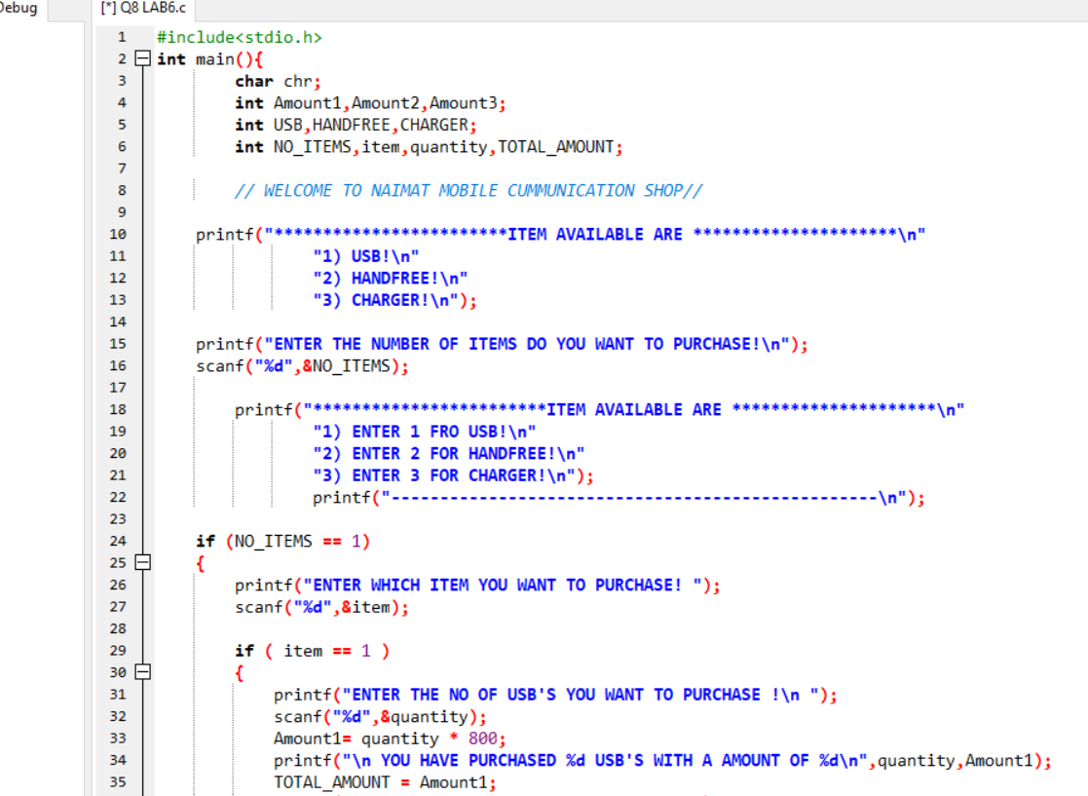

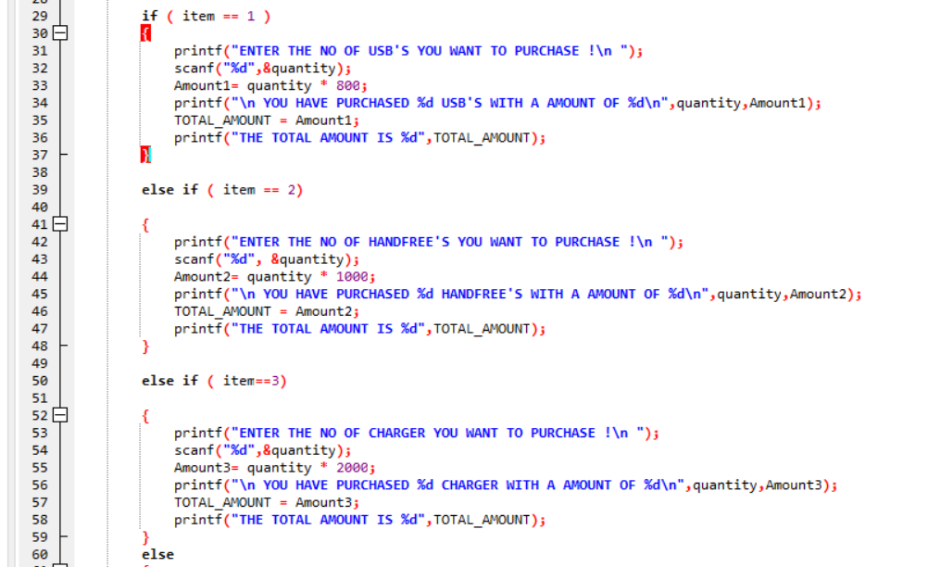

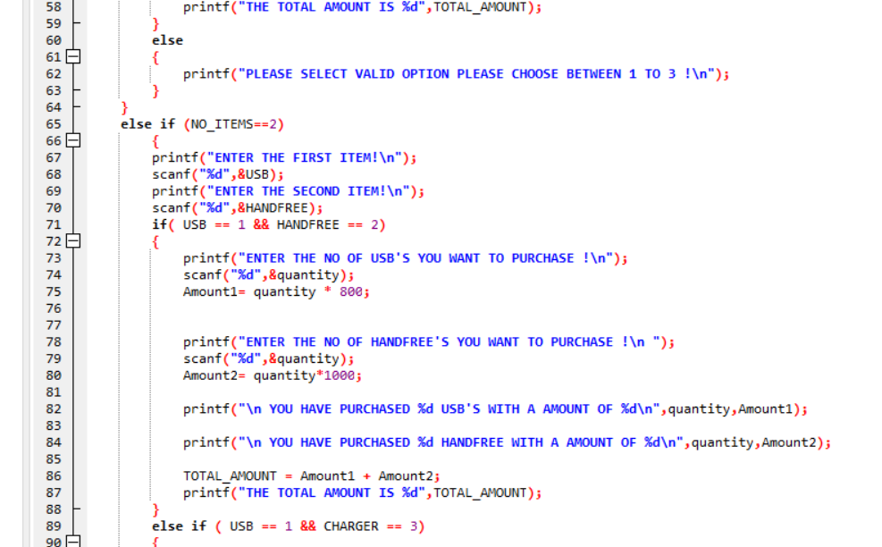

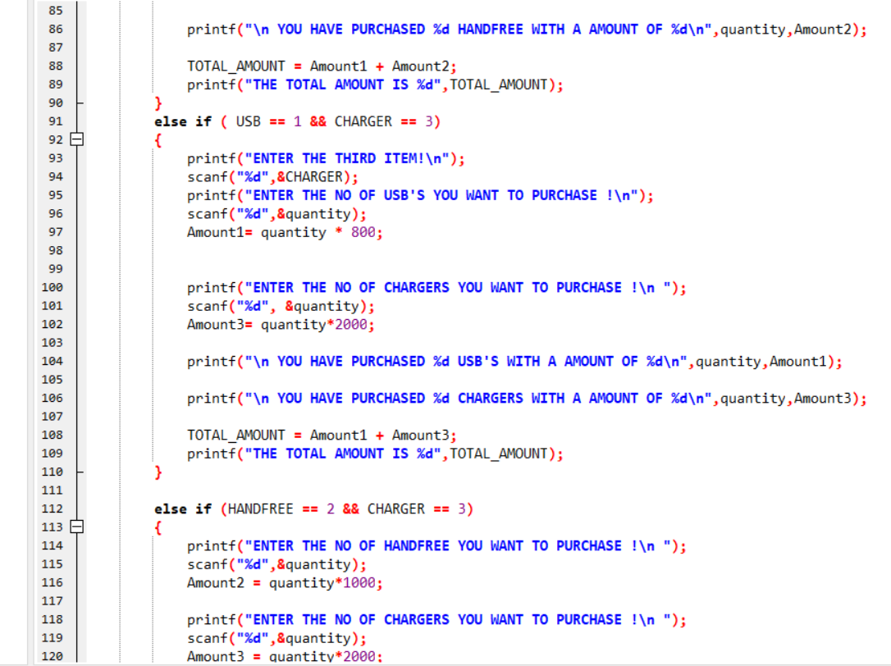

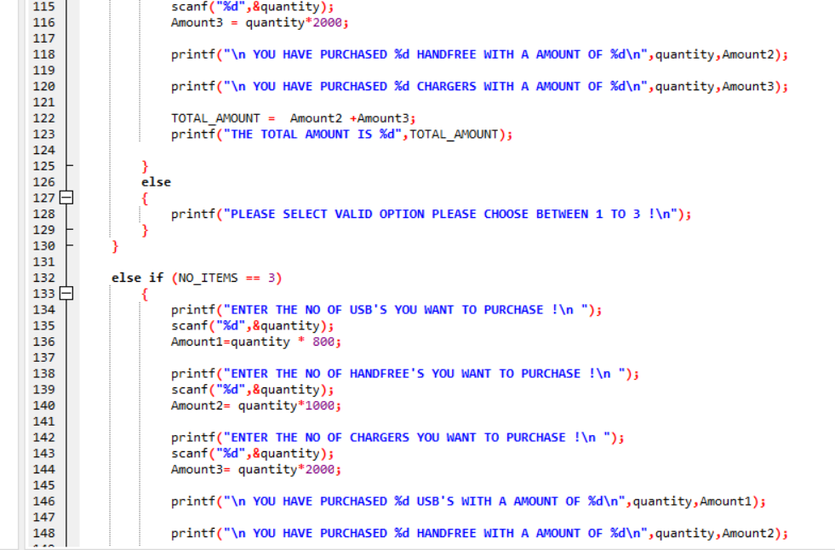

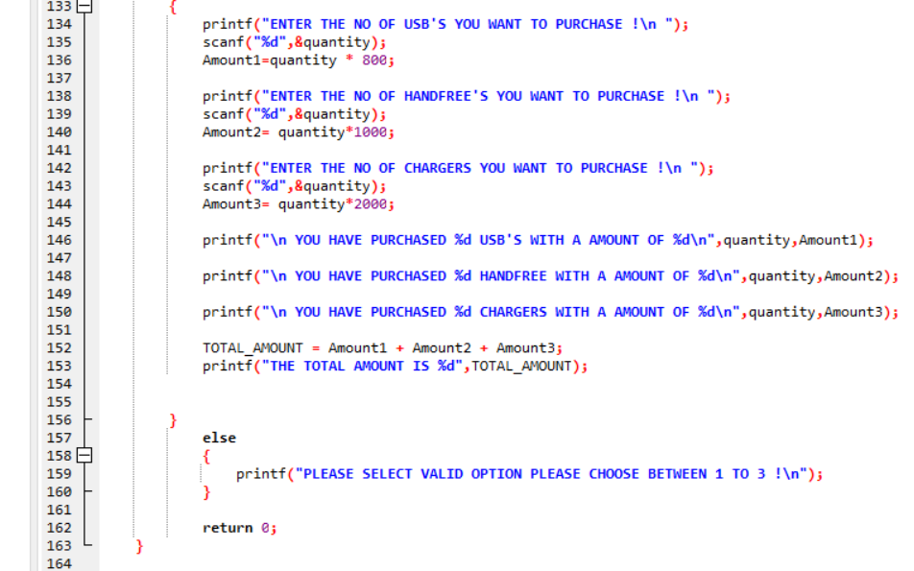

OUTPUT:

